

**Tribhuvan University Institute of Science and Technology**

**An Internship Mid-term Report**

On

**“Backend Development (Nest.JS)” At**

**Web Experts Nepal Pvt. Ltd.**

**Submitted to:**

Department of Computer Science and Information Technology Asian College of Higher Studies

Ekantakuna, Lalitpur

**In Partial Fulfillment of the requirements for the Bachelor of Science in Computer Science and Information Technology**

**Submitted By**

Kalyan Bhattarai (29205/078)

**SUPERVISOR'S RECOMMENDATION LETTER**

I hereby recommend that the report prepared under my supervision by Kalyan Bhattarai (TU Exam Roll No. 29205/078) entitled "Backend Development" at “Web Experts Nepal Pvt. Ltd.” in partial fulfillment of the requirements for the degree of B.Sc. in Computer Science and Information Technology be processed for evaluation.

..........................

Mr. Basant Karki

Internship Supervisor, Department of CSIT

Asian college of higher studies, Jawalakhel

**CERTIFICATE OF APPROVAL**

The undersigned certify that he has read and recommended to the Department of Computer Science and Information Technology for acceptance of an internship report entitled "NestJS Backend Developer Intern" submitted by Kalyan Bhattarai in partial fulfillment of the requirements for the degree of Bachelor of Science in Computer Science and Information Technology (BSc. CSIT), Institute of Science and Technology, Tribhuvan University.

Signature of Supervisor

…………………………

**Mr. Basant Karki**

Asian College of Higher Studies

Signature of HOD

…………………………

**Mr.Pranaya Nakarmi**

Asian College of Higher Studies

Signature of External Examiner

…………………………

**Mr……**

IOST, Tribhuvan University

# Acknowledgement

I would like to take this opportunity to express my sincere gratitude to Asian College of Higher Studies for providing quality education in the field of Computer Science and Information Technology, which has helped me strengthen both my theoretical knowledge and practical understanding. I am deeply appreciative of my respected supervisor, Mr. Basant Karki, for his valuable guidance, encouragement, and continuous support throughout the internship period; his mentorship played a significant role in helping me understand real-world software development practices and enhance my technical skills. I would also like to thank the entire faculty and administration of Asian College of Higher Studies for their constant support and cooperation. Furthermore, I am grateful to Web Experts Nepal Pvt. Ltd. for providing me with the opportunity to work as a Backend Developer Intern, where the professional working environment, technical exposure, and guidance from the development team greatly contributed to my learning and overall growth, and I sincerely thank my mentors and colleagues for their support, collaboration, and constructive feedback during the internship.

**Sincerely,**  
**Kalyan Bhattarai**

Department of Computer Science and Information Technology

Asian College of Higher Studies

29205/078

# Abstract

This report presents an overview of my internship experience at Web Experts Nepal Pvt. Ltd., where I worked on the development of a Project Management System (PMS) as a Backend Developer Intern. The project was developed using NestJS as the backend framework and PostgreSQL as the relational database. The primary focus of the project was to design and implement scalable and secure RESTful APIs, manage structured project data, and ensure efficient backend functionality. The internship, I worked on developing backend modules, controllers, and services, implementing authentication and role-based access, handling database relationships, and documenting APIs using Swagger. Tools such as Postman, Git/GitLab, and Trello were used for API testing, version control, and task management. This internship enhanced my practical understanding of backend application development, clean architecture, and professional software development workflows while strengthening my problem-solving and technical skills.

***Keywords:*** *Project Management System, NestJS, PostgreSQL, Backend Development, RESTful APIs*

Table of Contents

Acknowledgement iii

Abstract iv

LIST OF FIGURES vi

LIST OF TABLES vii

LIST OF ABBREVIATIONS viii

CHAPTER 1: INTRODUCTION 1

1.1 Introduction 1

1.2 Problem Statement 2

1.3 Objective 2

1.4 Scope and Limitations 2

1.5 Report Organization 3

CHAPTER 2: ORGANIZATION DETAILS 4

2.1 Introduction to Organization 4

2.2 Organizational Hierarchy 5

2.3 Working Domain of Organization 6

2.4 Description of Intern Department 6

2.5 Literature Review 7

CHAPTER 3: INTERNSHIP ACTIVITIES 10

3.1 Roles and Responsibilities 10

3.2 Weekly Log 11

3.3 Description of Project Involved During Internship 12

3.3.1 Duration 13

3.3.2 Tools Used 13

3.4 Task /Action Performed 14

CHAPTER 4: CONCLUSION AND LEARNING OUTCOMES 15

4.1 Conclusion 15

4.2 Learning Outcomes 15

REFERENCES 17

APPENDICES 18

# LIST OF FIGURES

Figure 2.1: Organizational Hierarchy of Web Experts Nepal Pvt. Ltd. 6

# LIST OF TABLES

Table 2.1: Contact Information of the Organization 4

Table 2.2: Internship Details 7

Table 3.1: Weekly Log 11

# LIST OF ABBREVIATIONS

|  |  |
| --- | --- |
| **API** | Application Programming Interface |
| **CORS** | Cross Origin Resource Sharing |
| **CRUD** | Create Read Update Delete |
| **DTO** | Date Transfer Object |
| **JSON** | JavaScript Object Notation |
| **JWT** | JSON Web Token |
| **PMS** | Project Management System |
| **RESTful** | Representational State Transfer |
|  |  |

# CHAPTER 1: INTRODUCTION

## 1.1 Introduction

A Project Management System (PMS) is an essential web-based backend application designed to facilitate the effective management of projects, tasks, users, and organizational workflows. In modern software-driven organizations, PMS platforms play a critical role in coordinating development activities, monitoring progress, and ensuring secure and efficient data handling. The system developed during this internship provides core backend functionalities such as user authentication, role-based access control, task assignment, project tracking, and secure API communication. The primary objective of the PMS is to streamline server-side operations while ensuring scalability, reliability, and maintainability in support of modern web applications.

This project focuses on backend development using NestJS, a progressive Node.js framework that supports modular architecture, dependency injection, and scalable application design. The backend architecture follows layered and modular design principles, enabling clear separation of concerns between controllers, services, and data access layers. RESTful APIs are implemented to ensure seamless communication between frontend interfaces and backend services, following widely accepted architectural standards (Fielding, 2000). Key backend responsibilities addressed in this project include business logic implementation, database management, API security, authentication and authorization, and performance optimization.

Internships serve as a vital platform for bridging the gap between academic learning and real-world industry practices. Through internships, students gain practical exposure to professional workflows, collaborative development environments, and industry-standard tools, while also developing technical and interpersonal skills (Zhang, 2020). The internship for this project was conducted at Web Experts Nepal, located in Satdobato, Lalitpur, a software development company specializing in web and backend solutions. The standard internship duration aligns with institutional requirements, typically spanning approximately ten weeks or 180 working hours (Technology, n.d.).

During the internship period, the intern worked as a Backend Developer Intern (NestJS) and was actively involved in designing and implementing backend modules for the Project Management System. The assigned responsibilities included developing RESTful APIs, implementing authentication and authorization mechanisms, managing database interactions using PostgreSQL, and integrating backend services with frontend components. Industry-standard tools such as Git were used for version control, Swagger for API documentation, and Postman for API testing. Under professional mentorship, the internship experience enhanced practical understanding of real-world backend development practices, software architecture principles, and collaborative development workflows. Overall, the internship significantly strengthened technical skills, problem-solving abilities, and professional readiness for software engineering roles.

## 1.2 Problem Statement

Traditional academic projects and basic backend implementations often lack scalable architecture, secure API design, and efficient data management required for real-world applications. Many systems are poorly structured, difficult to maintain, and do not follow modern backend development practices such as modular design, authentication, authorization, and performance optimization. Therefore, there is a need for a well-designed and scalable backend system like the Project Management System (PMS) developed using NestJS, which provides structured server-side architecture, secure RESTful APIs, efficient database handling, and flexibility to adapt to real-world application requirements.

## 1.3 Objective

The specific objectives of the project are as follows:

* To design and develop a scalable and well-structured backend system using NestJS for managing projects, users, and tasks efficiently.
* To implement secure and efficient RESTful APIs, including authentication and authorization mechanisms, to support reliable communication between frontend and backend components.
* To manage database operations effectively using PostgreSQL, ensuring data integrity, performance, and smooth handling of backend business logic.

## 1.4 Scope and Limitations

There are certain scopes and limitations associated with the PMS Backend project, which are outlined below:

**Scope of the Project:**

* Development of a backend system for a Project Management System (PMS) using NestJS.
* Implementation of RESTful APIs for managing users, projects, and tasks.
* User authentication and authorization with role-based access control.
* Database management using PostgreSQL.
* Integration of backend APIs with frontend applications.

**Limitations of the Project:**

* Requires an active internet connection for system access.
* Advanced analytics and real-time notification features are not included.
* Limited third-party service integration.
* Designed for small to medium-scale usage; may need optimization for large-scale deployment.

## 1.5 Report Organization

This report is organized into four main chapters, each designed to systematically present the internship work and its outcomes.

**Chapter 1: Introduction**

This chapter provides an overview of the internship project, including its background, problem statement, objectives, and the scope and limitations of the study. It offers a general understanding of the project and sets the context for the subsequent chapters.

**Chapter 2: Organizational Details and Literature Review**

This chapter presents an overview of the host organization, including its organizational structure, operational domains, and departmental functions relevant to the internship. It also includes a literature review of related systems, technologies, and architectural approaches that support the development of the project, providing theoretical and technical foundations.

**Chapter 3: Internship Activities**

This chapter details the activities carried out during the internship period. It describes the roles and responsibilities assigned, weekly progress records, project implementation processes, and the tools and technologies used during development. The chapter highlights practical contributions and technical tasks performed throughout the internship.

**Chapter 4: Conclusion and Learning Outcomes**

This chapter summarizes the overall internship experience and project outcomes. It highlights the key learning achievements, skills gained, challenges faced, and professional insights acquired during the internship, concluding the report with reflections on personal and technical growth.

# CHAPTER 2: ORGANIZATION DETAILS

## 2.1 Introduction to Organization

The global information technology (IT) industry plays a crucial role in driving digital transformation across businesses and industries worldwide. Rapid advancements in web technologies, cloud computing, and software engineering practices have significantly changed how organizations operate and deliver services. Businesses increasingly depend on digital platforms to improve operational efficiency, enhance customer engagement, and gain competitive advantage. As a result, the demand for scalable, secure, and user-centric software solutions has grown substantially, making web application development and custom software services key components of the global digital economy.

In the national context, Nepal’s IT sector has experienced steady growth in recent years, supported by increased internet penetration, the expansion of digital services, and a growing pool of skilled IT professionals. Nepali software companies are actively contributing to both domestic and international markets by offering web development, software outsourcing, and IT consultancy services. The rise of startups and technology-focused enterprises has further strengthened the country’s digital ecosystem, creating opportunities for innovation, employment, and skill development. Internship and training programs offered by IT companies play an important role in preparing students and graduates to meet industry demands and global standards.

Within this national landscape, Web Experts Nepal is a professional IT company located in Satdobato, Lalitpur, dedicated to delivering modern, reliable, and efficient digital solutions. The company specializes in full-stack web application development, custom software development, and a wide range of digital services designed to help businesses succeed in today’s competitive technology- driven environment.

With a skilled team of developers and technical experts, Web Experts Nepal focuses on building secure, scalable, and user-friendly web applications. The company emphasizes clean architecture, efficient backend systems, and modern development practices to deliver high-quality products that support client growth and digital transformation.

In addition to development services, Web Experts Nepal actively promotes knowledge- sharing and skill development by fostering an environment that supports internships and early-career training. This approach provides students and junior developers with exposure to real projects, industry tools, and modern workflows, enabling them to build a strong technical foundation and gain hands-on experience.

Guided by principles of commitment, innovation, and customer satisfaction, Web Experts Nepal continues to grow as a reliable technology partner in Nepal’s IT sector. The company aims to provide trustworthy digital solutions while supporting the next generation of IT professionals through mentorship and real-world project involvement.

Table 2.1: Contact Information of the Organization

|  |  |
| --- | --- |
| **Field** | **Details** |
| **Name** | Web Experts Nepal |
| **Location** | Satdobato, Lalitpur, Nepal |
| **Phone** | 15533059 |
| **Email** | info@webexpertsnepal.com |
| **Number of Employees** | 36 |

## 2.2 Organizational Hierarchy

Web Experts Nepal Pvt. Ltd. is a growing web solutions company with a collaborative organizational structure designed to deliver high-quality digital products and services. The organization follows a well-defined hierarchical structure that ensures effective communication, proper task delegation, and smooth project execution across departments.

At the top of the organizational hierarchy is the Chief Executive Officer (CEO), who is responsible for overall vision, strategic planning, and business growth. The Chief Technology Officer (CTO) oversees technical leadership, system architecture decisions, and development standards, while the Chief Operating Officer (COO) manages daily operations and coordinates administrative activities. The Project Manager plays a vital role in planning, assigning tasks, monitoring progress, and ensuring timely delivery of client requirements. Administrative and human resource responsibilities are handled by the HR and Admin department, which manages internal operations, employee coordination, and organizational policies.

The organization is further divided into specialized technical teams, including Frontend Development (React), Backend Development (NestJS), WordPress Development, and UI/UX Design. These teams work collaboratively to deliver efficient and scalable digital solutions while maintaining development quality and performance standards.

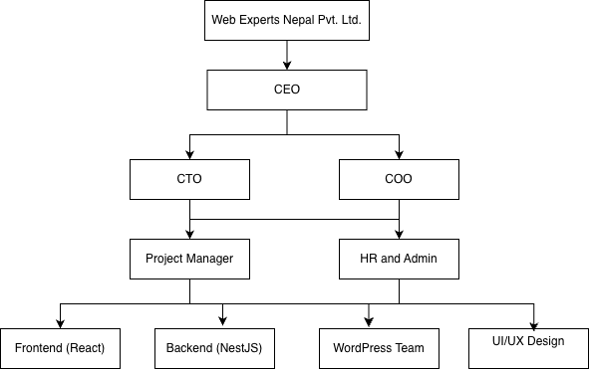

Figure 2.1: Organizational Hierarchy of Web Experts Nepal Pvt. Ltd.

The figure presents the organizational hierarchy of Web Experts Nepal Pvt. Ltd. in a structured visual format. The diagram highlights the top-level management led by the Chief Executive Officer (CEO), followed by the Chief Technology Officer (CTO) and Chief Operating Officer (COO), reflecting the division of technical and operational responsibilities within the organization.

The figure further illustrates the role of the Project Manager in coordinating project execution between management and development teams. It also shows the HR and Admin department supporting organizational operations. At the operational level, the diagram depicts specialized development teams such as Frontend (React), Backend (NestJS), WordPress, and UI/UX Design, which are responsible for implementing technical solutions. This hierarchical representation demonstrates clear reporting relationships, efficient workflow management, and collaborative team coordination within the organization.

## 2.3 Working Domain of Organization

Web Experts Nepal Pvt. Ltd. is a web solutions and software development company that provides high-quality digital services to clients both within Nepal and internationally. The organization focuses on delivering reliable, scalable, and user-centric solutions by leveraging modern web technologies and industry best practices.

The company operates across multiple working domains, which include:

Web Design and Development (including WordPress-based websites, theme and plugin development)

Web Application Development (custom and enterprise-level applications)

Backend Development (scalable server-side applications using technologies such as NestJS)

UI/UX Design (interactive interfaces, prototyping, and user-focused design)

React and Single-Page Application Development

Website Optimization and Security (performance, load time, and security enhancements)

IT Consultancy and Maintenance Services

Through these domains, Web Experts Nepal aims to provide complete web-based solutions that meet client requirements while maintaining high standards of quality, performance, and usability.

## 2.4 Description of Intern Department

Web Experts Nepal Pvt. Ltd. has a structured and effective intern department designed to support practical learning and professional development. Interns are assigned to relevant technical teams based on their skills and project requirements and are supervised by experienced developers who act as mentors.

At the beginning of the internship, mentors provide an overview of the working environment, development workflow, and a learning roadmap covering technologies relevant to the assigned project. Interns initially study these technologies using available online resources and internal documentation. As the internship progresses, mentors provide deeper technical guidance and assign practical tasks or small project modules to enhance hands-on experience.

Throughout the internship period, interns are assigned tasks related to fixing existing issues, improving system functionality, and developing new features based on project requirements. Task assignments, progress tracking, and deadlines are managed using Trello, while Git/GitLab is used for version control and code collaboration. Interns are required to report daily progress and task completion status to their mentors. Upon task completion, the mentor reviews the code for correctness, efficiency, and maintainability. After incorporating the feedback, the approved code is merged into the development branch.

Table 2.2: Internship Details

|  |  |
| --- | --- |
| **Company Name** | **Web Experts Nepal Pvt. Ltd.** |
| **Internship Position** | **NestJS Backend Developer Intern** |
| **Project** | **Project Management System (PMS)** |
| **Start Date** | **17th Sep, 2025** |
| **End Date** | **17th Dec, 2025** |
| Mentor | Ashis Chettri |
| **Working Days** | **Monday to Friday** |
| **Working Hours** | **9:00 AM – 6:00 PM** |

## 2.5 Literature Review

Project Management Systems (PMS) have become an integral component of modern organizations for the efficient management of projects, tasks, users, and workflows. With the growing dependence on web-based information systems, PMS platforms are increasingly developed using scalable backend architectures that ensure secure data handling, role-based access control, and efficient communication between system components. These systems support planning, execution, monitoring, and collaboration, enabling organizations to manage complex projects more effectively.

According to Pressman and Maxim (2015), well-structured software systems should follow modular and layered architectural principles to enhance maintainability, scalability, and reliability. Modern PMS applications are therefore expected to incorporate essential backend features such as user authentication, authorization mechanisms, task tracking, and secure data management to support collaborative organizational workflows. Adherence to such architectural principles allows backend systems to evolve over time while maintaining stability and performance.

With advancements in web technologies, backend development has emerged as a critical component of web-based applications. Fielding (2000) introduced the concept of REST, which defines architectural constraints for designing scalable and stateless network-based systems. RESTful APIs have since become widely adopted due to their simplicity, flexibility, and compatibility with distributed application architectures. PMS platforms commonly rely on RESTful APIs to facilitate seamless communication between frontend interfaces and backend services, ensuring interoperability and scalability.

Recent industry practices highlight the widespread adoption of Node.js-based backend frameworks for building high-performance and scalable web applications. NestJS, a progressive Node.js framework, offers a structured architecture based on modules, controllers, and services, along with built-in support for dependency injection. Technical documentation and industry studies indicate that NestJS improves code organization, testability, and scalability compared to traditional unstructured backend implementations (NestJS Official Documentation, 2024). These characteristics make NestJS suitable for enterprise-level backend systems such as PMS applications.

Database management is another critical component of Project Management Systems, as they handle structured data including users, projects, tasks, and activity logs. Relational database management systems (RDBMS) such as PostgreSQL are widely used due to their strong support for data integrity, relational constraints, and transaction management. Literature suggests that PostgreSQL is particularly suitable for enterprise applications because of its reliability, advanced query optimization capabilities, and support for complex relational data models (PostgreSQL Global Development Group, 2024).

In addition to core backend technologies, software engineering literature emphasizes the importance of API documentation, testing, and version control in professional development environments. Tools such as Swagger enable standardized API documentation, improving clarity and ease of integration for developers, while Postman is commonly used for API testing and validation. Furthermore, version control systems like Git support collaborative development by enabling code tracking, branching, and structured workflow management (Git Documentation, 2024).

Based on the reviewed literature, the Project Management System developed during this internship aligns with established backend development standards and best practices. The adoption of modular architecture, RESTful APIs, secure authentication mechanisms, relational database management, and professional development tools reflects both academic research and industry practices. This alignment validates the technical approach implemented during the internship and demonstrates its relevance to modern backend system development.

# CHAPTER 3: INTERNSHIP ACTIVITIES

## 3.1 Roles and Responsibilities

During the internship period at Web Experts Nepal, the intern worked as a Backend Developer, primarily focusing on backend development using NestJS. The internship was conducted under the supervision of experienced developers, providing the opportunity to work on real-world projects and follow professional development workflows. Through close collaboration with team members, the intern actively contributed to backend system design and API development while gaining practical industry experience.

The major roles and responsibilities performed during the internship are listed below:

Designed and developed a modular, secure, and scalable backend architecture using NestJS.

* Implemented RESTful APIs to support core functionalities such as user management, project handling, task assignment, comments, and file attachments.
* Integrated databases with the backend to manage data storage, retrieval, and manipulation efficiently.
* Applied authentication and authorization mechanisms, including role-based access control, to ensure system security.
* Wrote clean, maintainable, and well-structured code following industry best practices.
* Optimized API performance and improved backend efficiency to support scalable application growth.
* Collaborated with frontend developers and team members to ensure smooth communication between system components.
* Debugged, tested, and resolved backend issues to maintain application stability and reliability.
* Followed version control standards and development workflows while contributing to live projects.

## ****3.2 Weekly Log****

Table 3.1: Weekly Log

|  |  |  |
| --- | --- | --- |
| Week | Focus Area | Summary of Tasks Completed |
| Week 1 | Internship Induction & System Setup | • Learned about the organization’s workflow, expectations, and development practices  •Installed and configured necessary tools for backend development  • Reviewed project objectives and backend requirements  • Created and initialized the project repository |
| Week 2 | Application Base Configuration | • Established the initial NestJS application structure  • Organized directories based on modular design principles  • Configured core dependencies and environment variables |
| Week 3 | Data Model Design | • Identified required database entities for the project  • Structured relationships among entities to support system functionality  • Defined basic validation rules and data flow |
| Week 4 | Backend Component Setup | • Created core backend components including controllers and services  • Implemented data transfer objects and interfaces  • Followed clean architecture principles for maintainability |
| Week 5 | Core Feature Module Development  (Project Module) | • Implemented Project module including controller, service, and entity  • Designed CRUD APIs for project creation, update, retrieval, and deletion  • Established project ownership and basic access rules  • Implemented DTOs and request validation for project APIs |
| Week 6 | Task & Subtask Module Development | • Developed Task module with full CRUD functionality  • Implemented Subtask module linked to parent tasks  • Added task status, priority, and assignment logic  • Connected tasks and subtasks with projects using relational mappings |
| Week 7 | Collaboration Features (Comment & Attachment Modules) | • Implemented Comment module for task-based communication  • Developed Attachment module for associating files with tasks  • Linked comments and attachments to tasks and users  • Ensured validation and secure data handling |
| Week 8 | File Management, Pagination & Search Integration | • Integrated Cloudinary service for file uploads and storage  • Implemented file upload APIs using Cloudinary  • Added pagination logic to support large datasets and graph-ready responses  • Implemented search functionality across projects and tasks |
| Week 9 | Reporting & Data Analysis APIs | • Built APIs to provide summarized project and task data  • Implemented database queries for performance and progress analysis |
| Week 10 | System Optimization & Protection | • Improved backend efficiency through query optimization  • Applied request rate control mechanisms Strengthened application security configurations |
| Week 11 | Quality Assurance | • Performed backend testing and bug fixing  • Improved reliability and stability of implemented features |
| Week 12 | Documentation & Finalization | • Prepared detailed API documentation using Swagger  • Reviewed overall system implementation  • Completed final internship deliverables |
| Week 13 | Basic DevOps  Tools and  CI/CD during  deployment | • Studied basic DevOps concepts and tools.  • Learned and implemented continuous integration and continuous deployment (CI/CD) pipelines using GitLab CI/CD for automated build and deployment processes. |

Week 1: Internship Induction & System Setup

During the first week, the intern focused on understanding the organization’s working environment, backend development workflow, and project expectations. The project requirements for the Project Management System (PMS) were reviewed in detail under mentor guidance. Necessary development tools such as Node.js, NestJS CLI, PostgreSQL, Git, and Visual Studio Code were installed and configured. The backend project repository was initialized using Git, and the base NestJS project was created.

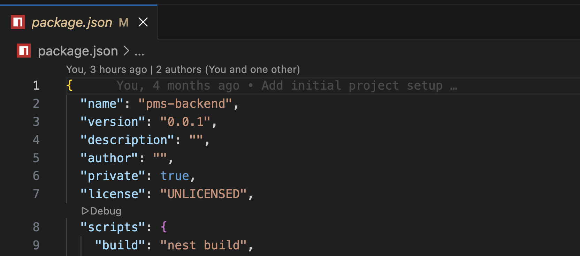

Week 2: Application Base Configuration

In the second week, the foundational structure of the NestJS application was established. The project was organized following modular architecture principles recommended by NestJS. Environment variables were configured using .env files, and essential dependencies were installed. The application entry point and core modules were verified to ensure smooth startup and scalability.

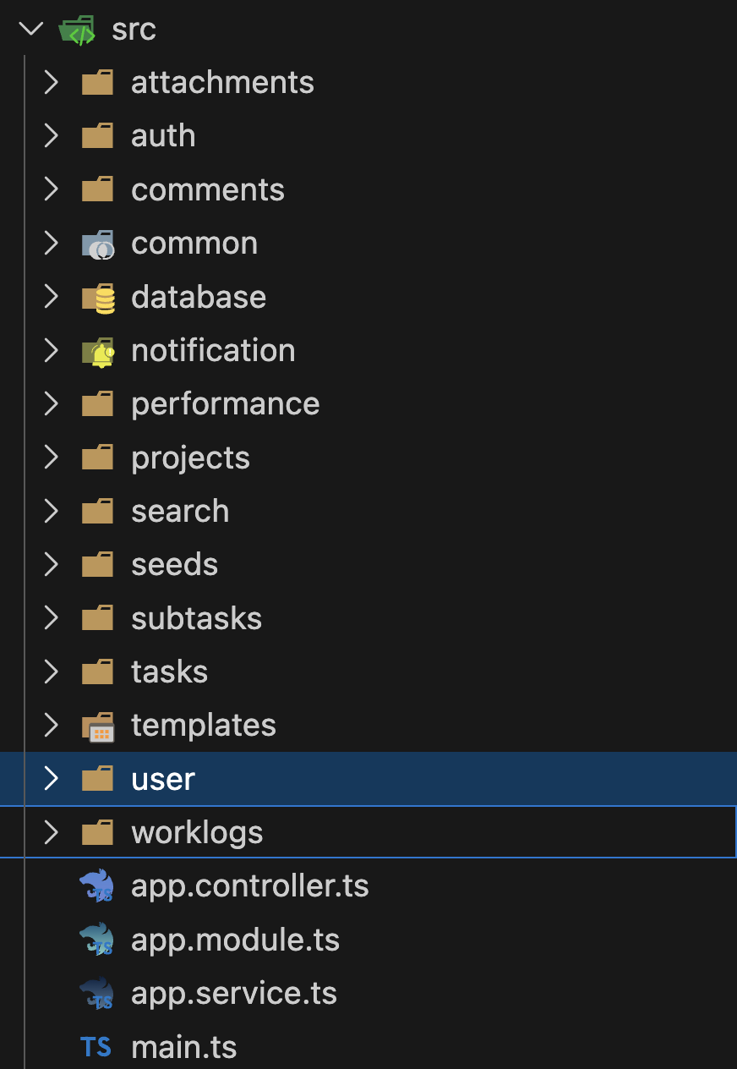

Week 3: Data Model Design

This week focused on designing the database structure for the PMS. Required entities such as Project, Task, Subtask, Attachment, and Comment were identified. Relationships between entities were structured using foreign keys to ensure data integrity. Validation rules and data flow between modules were also defined.

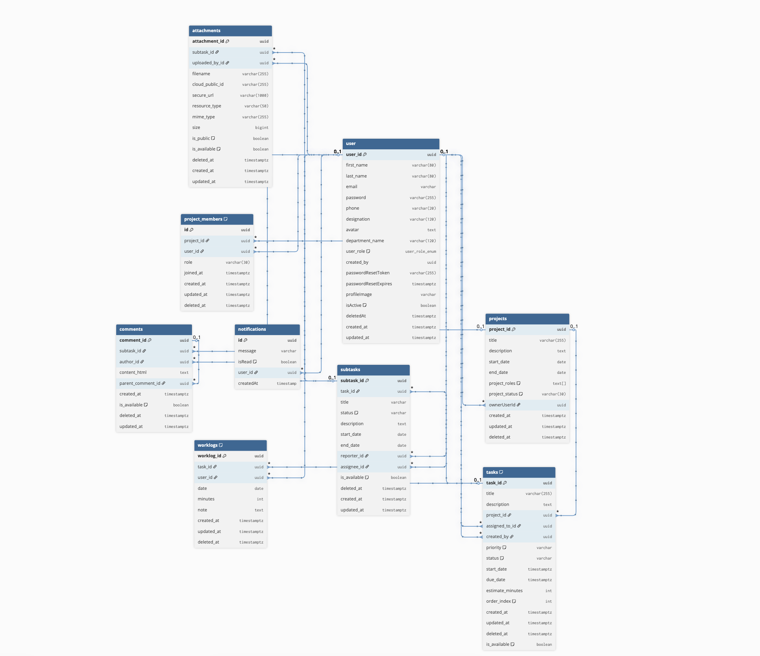

Week 4: Backend Component Setup

Core backend components were developed following clean architecture principles. Controllers and services were created to define request handling and business logic. Data Transfer Objects (DTOs) and interfaces were implemented to validate incoming requests and standardize API responses.

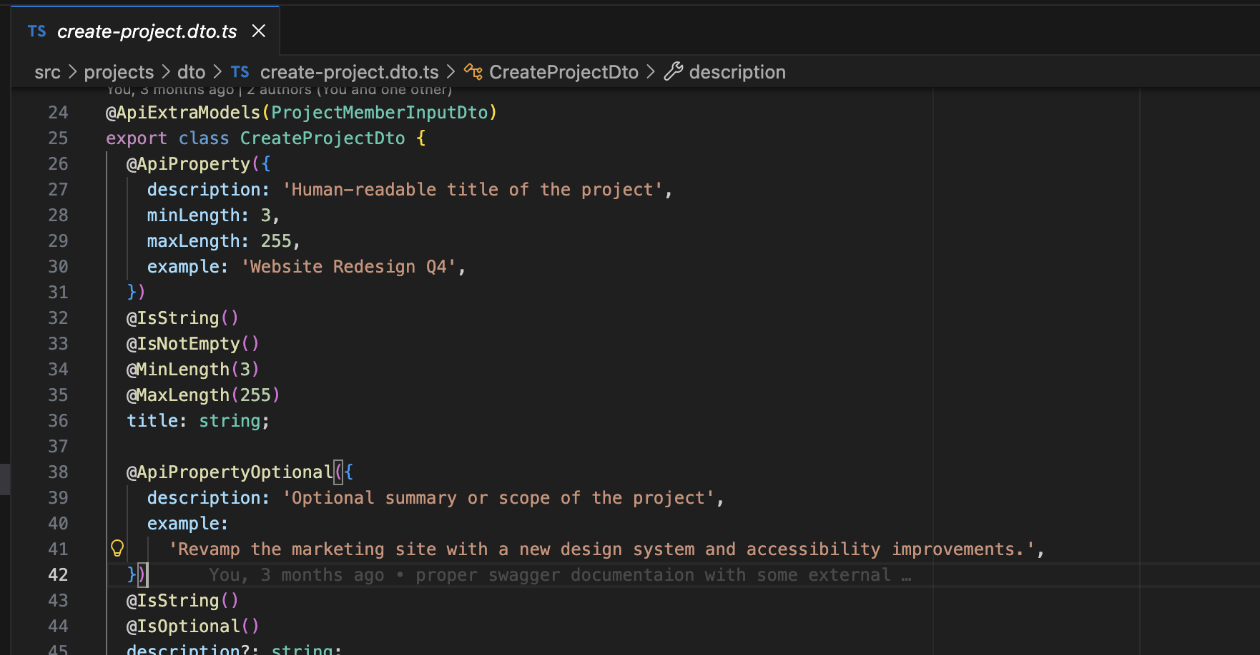

Week 5: Core Feature Module Development (Project Module)

In this week, the Project module was fully implemented. CRUD APIs were developed to allow project creation, update, retrieval, and deletion. Project ownership rules were established, and request validation was enforced using DTOs to ensure secure and structured data handling.

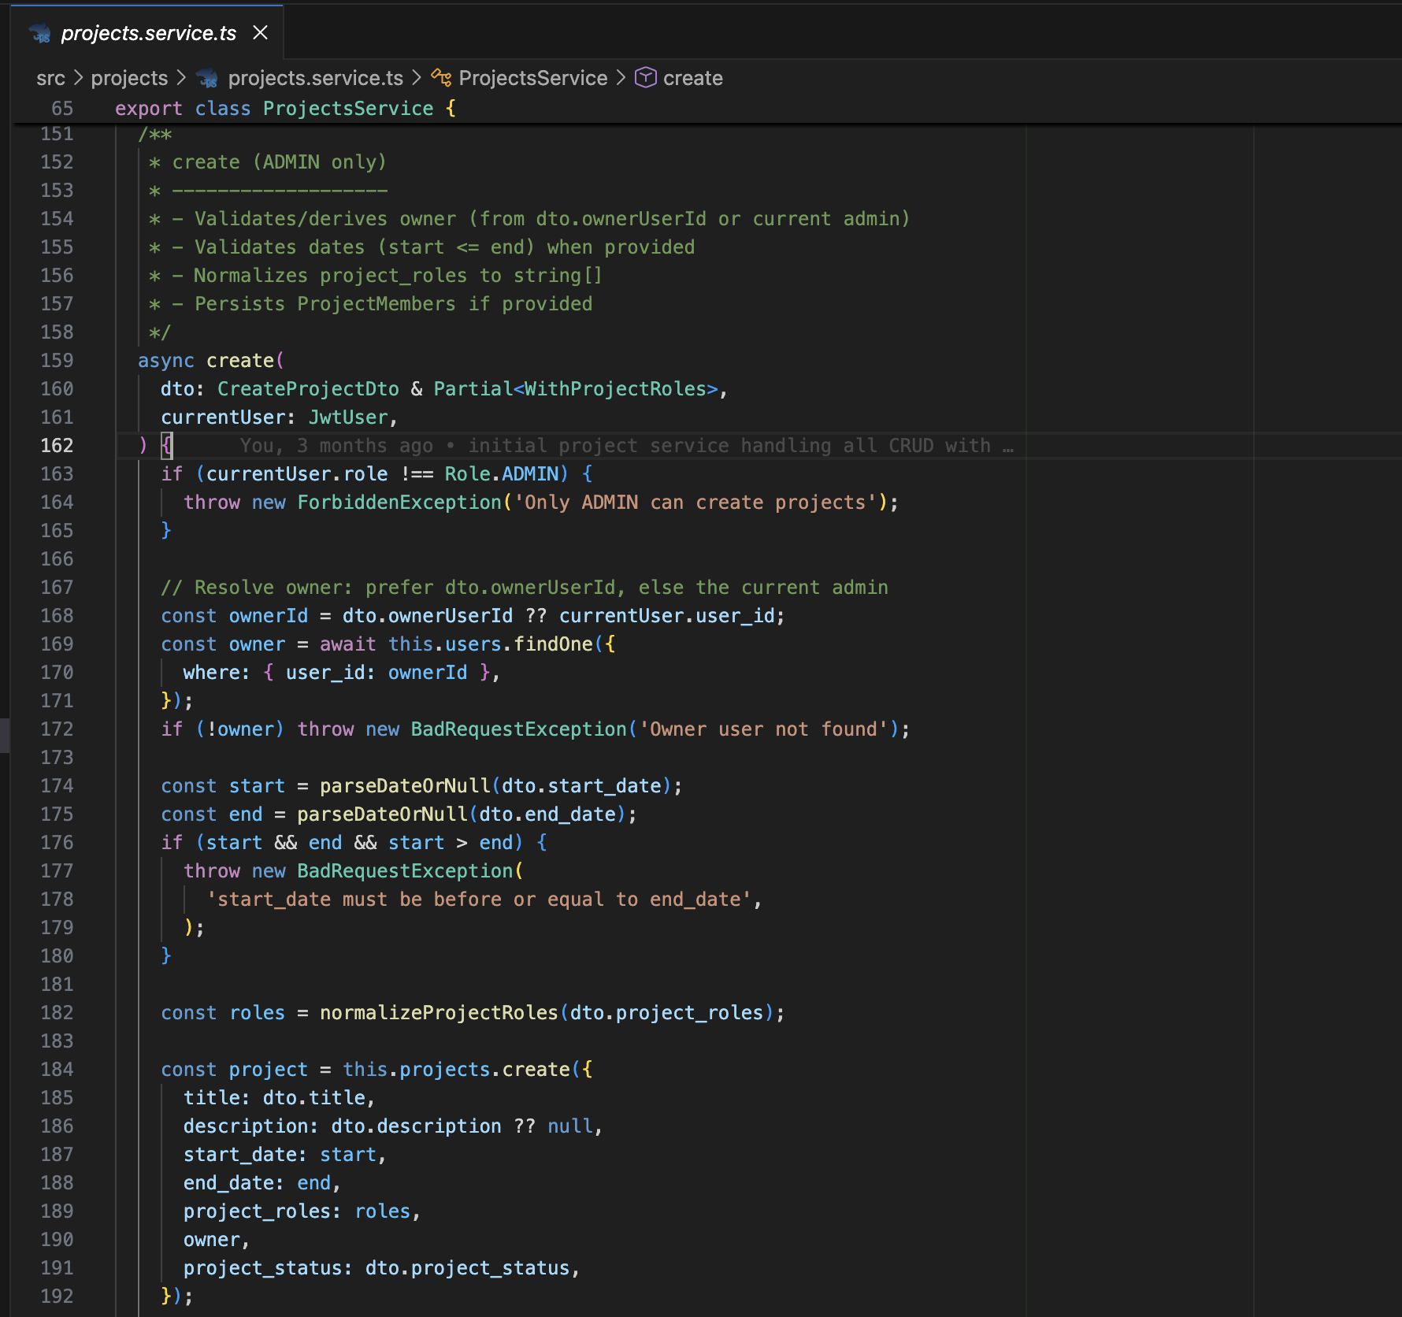

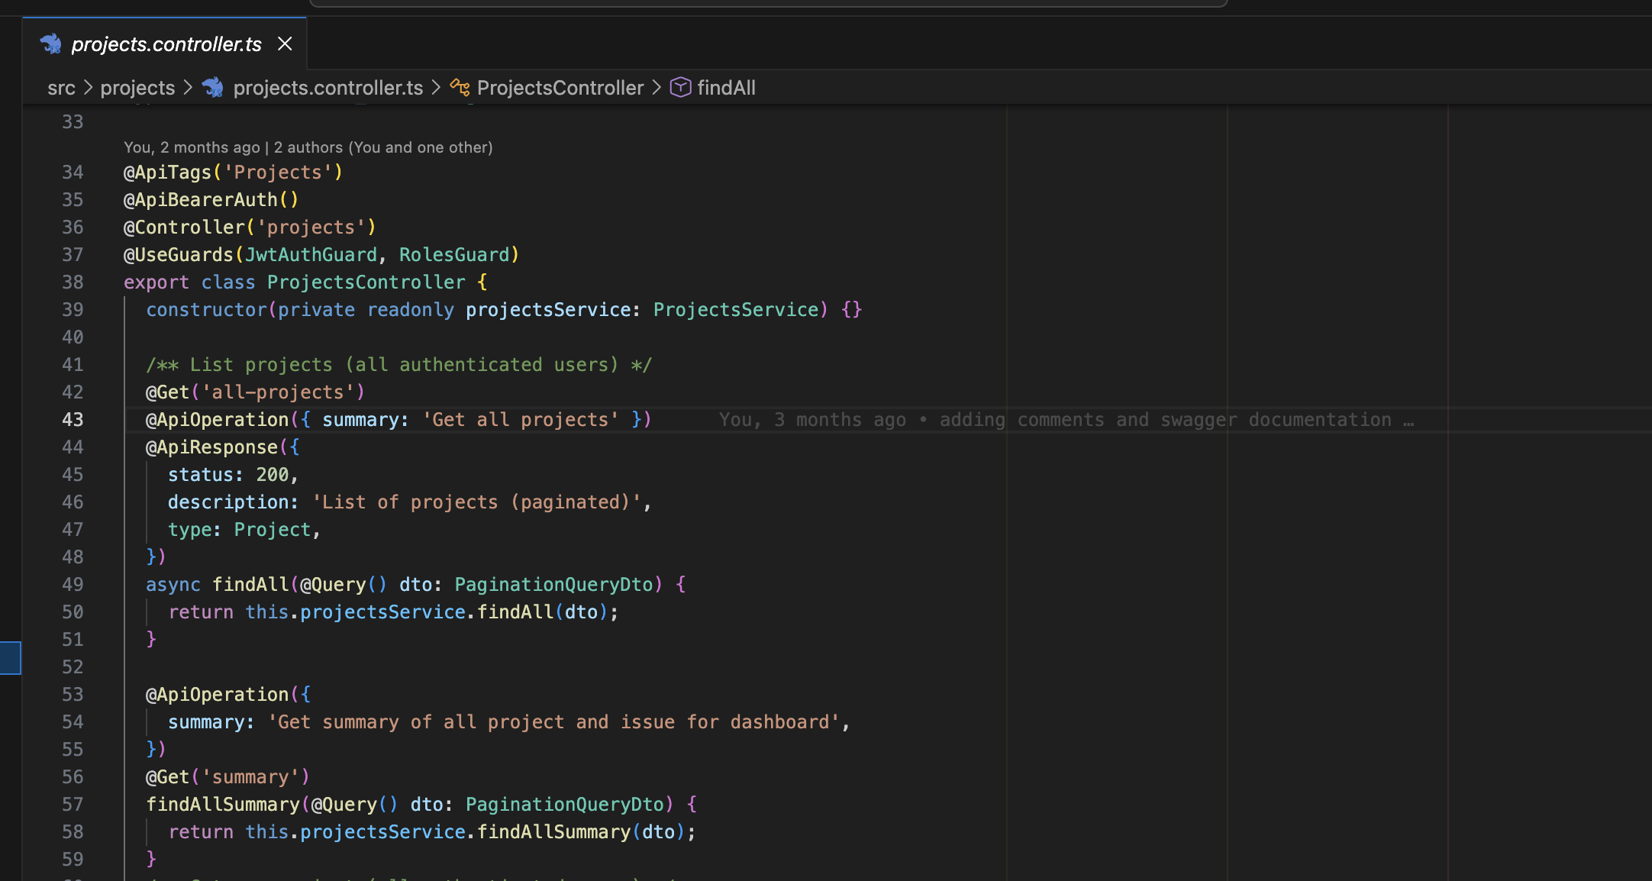

Week 6: Task & Subtask Module Development

This week focused on task management features. The Task module was implemented with full CRUD functionality, followed by the Subtask module, which was linked to parent tasks. Task status, priority, and assignment logic were added, and tasks were connected to projects using relational mappings.

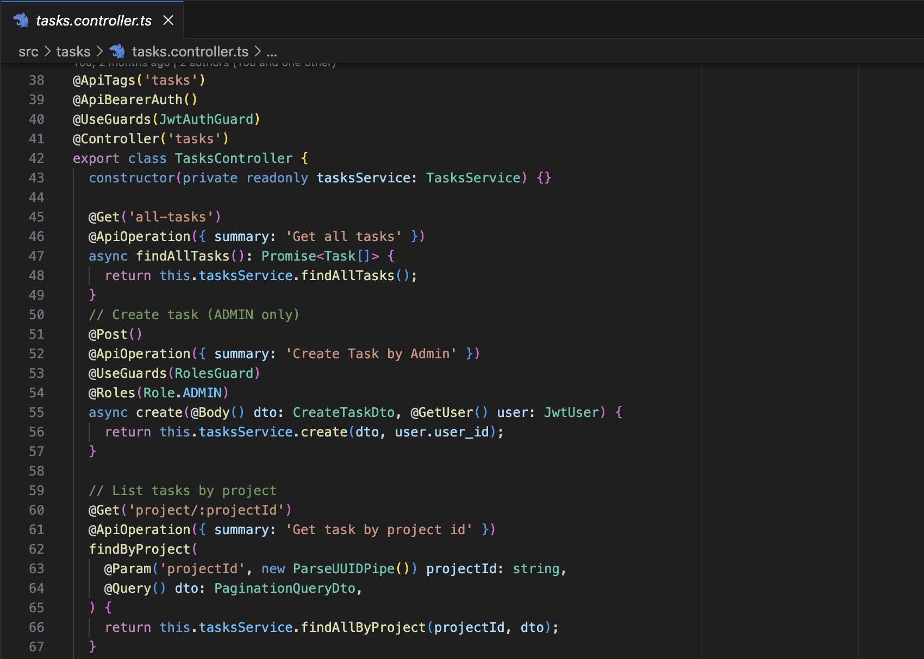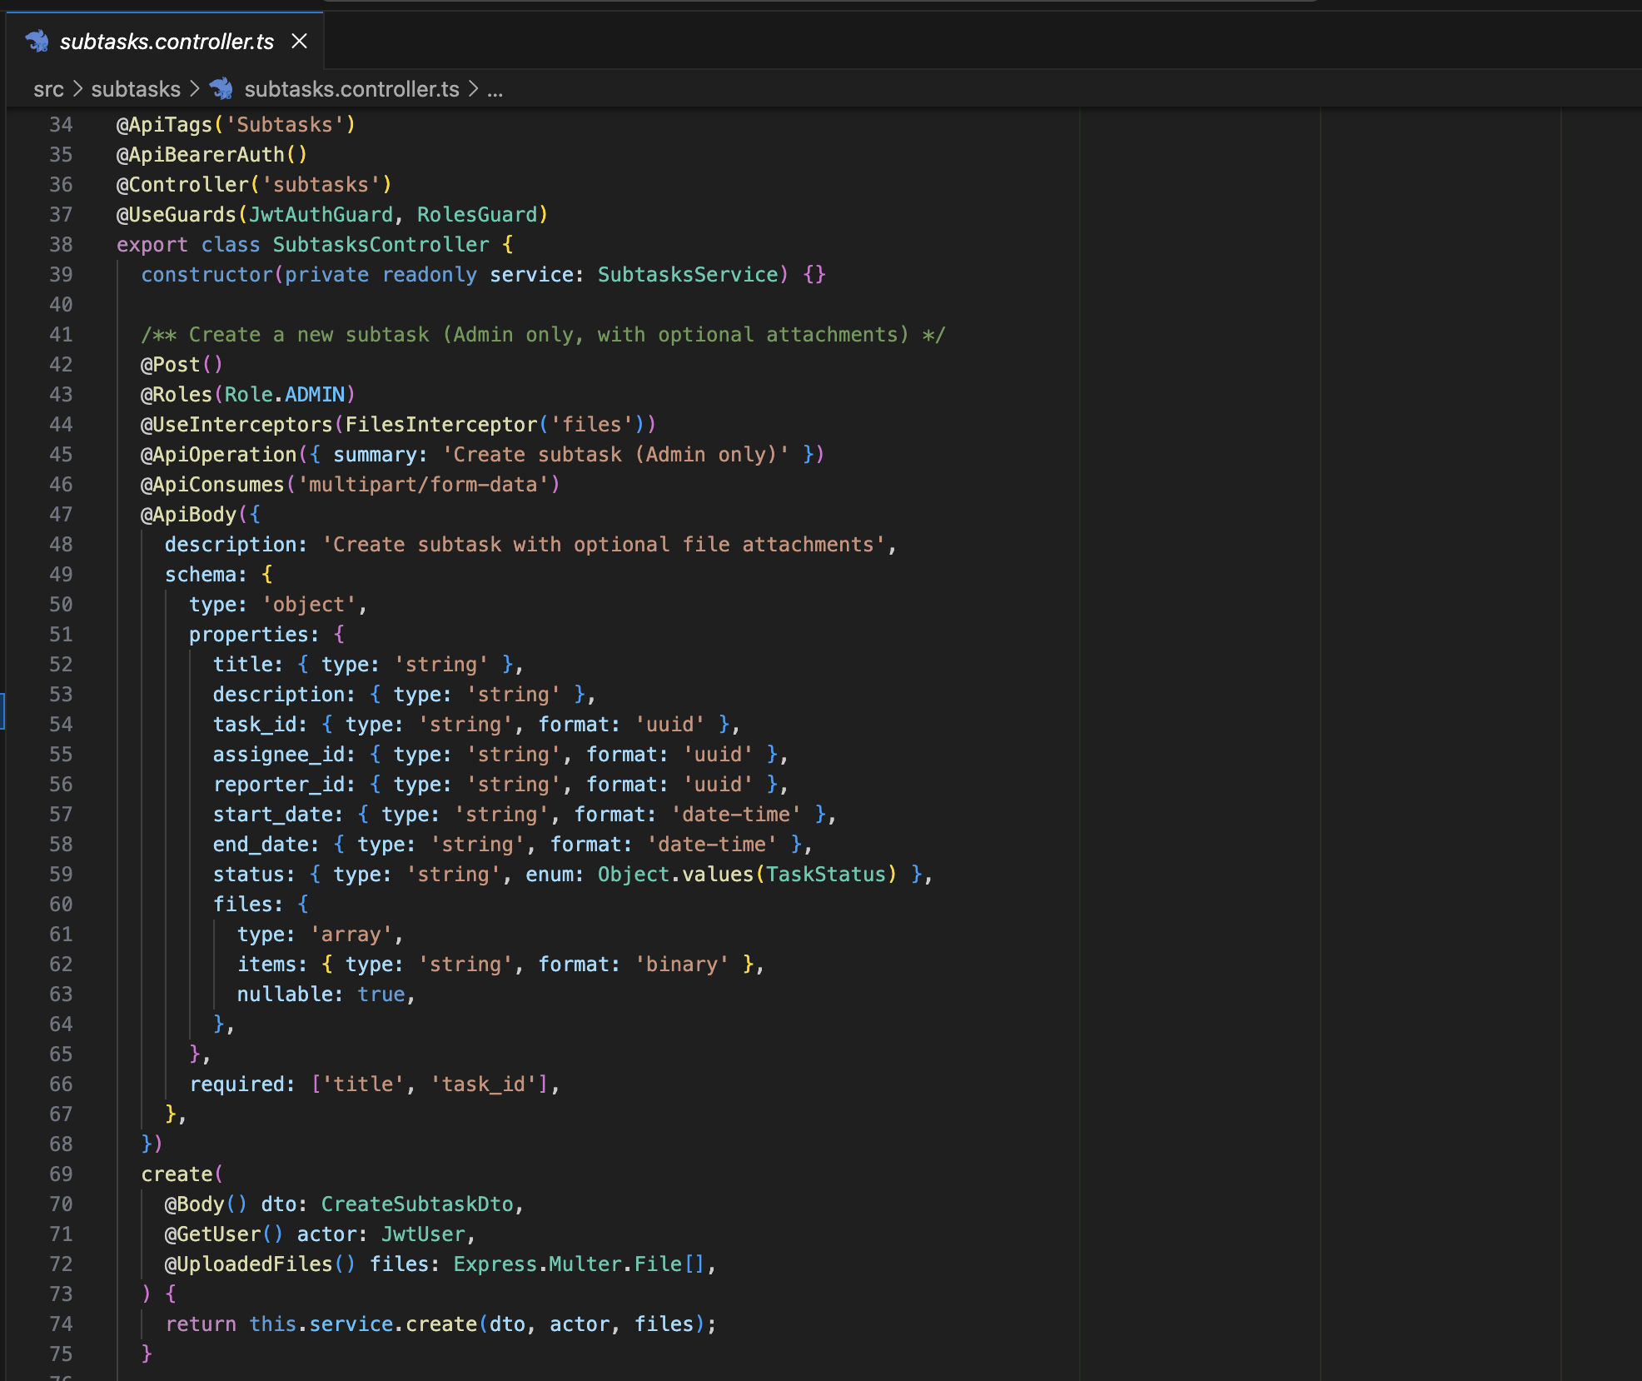

Week 7: Collaboration Features (Comment & Attachment Modules)

During this week, collaboration-related features were developed. The Comment module enabled task-based communication among users. The Attachment module allowed files to be associated with tasks. Relationships between comments, attachments, tasks, and users were established with proper validation and security checks.

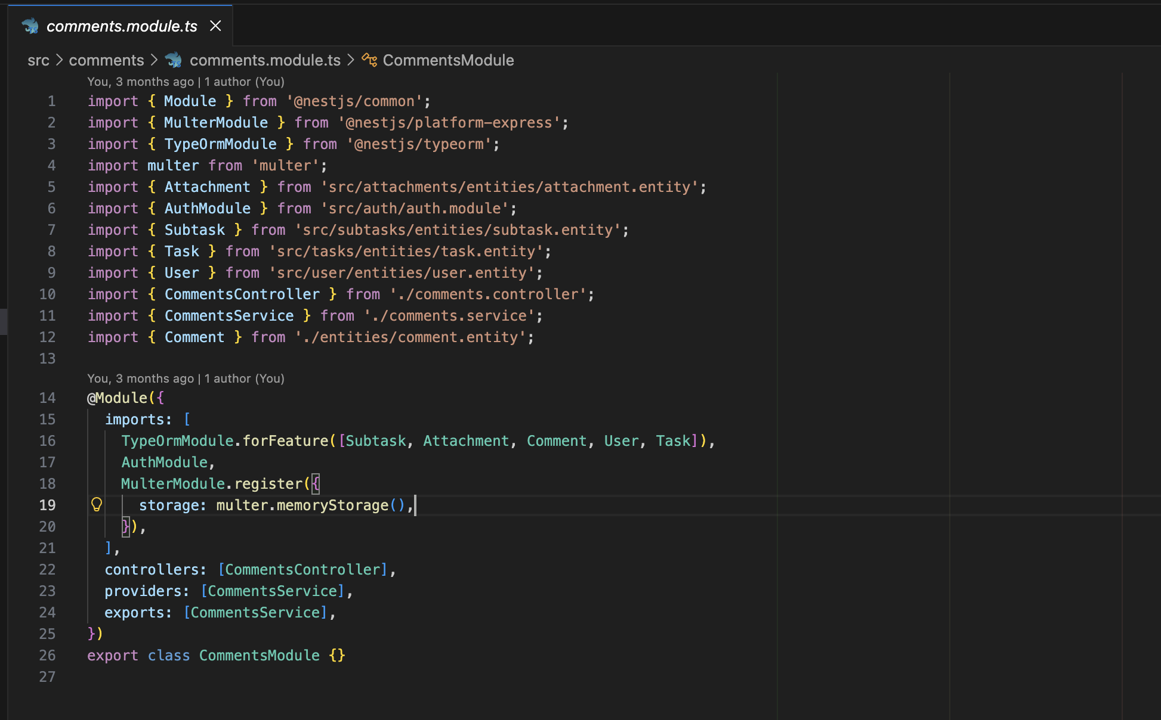

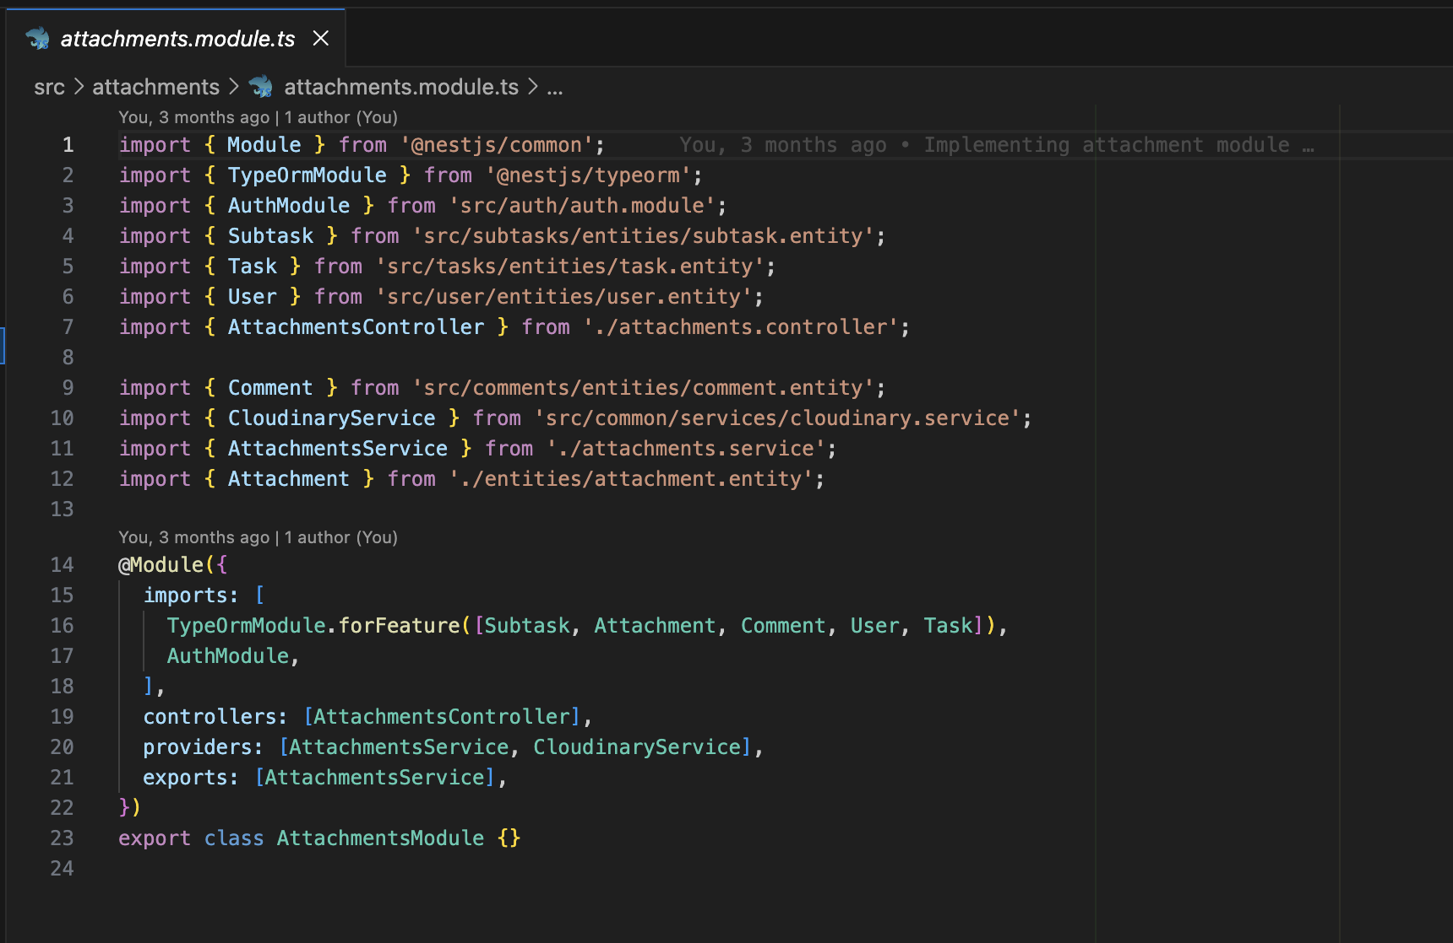

Week 8: File Management, Pagination & Search Integration

This week focused on improving data handling and scalability. Cloudinary services were integrated for file upload and storage. Pagination logic was implemented to handle large datasets efficiently and support graph-ready responses. Search functionality was added to allow filtering of projects and tasks.

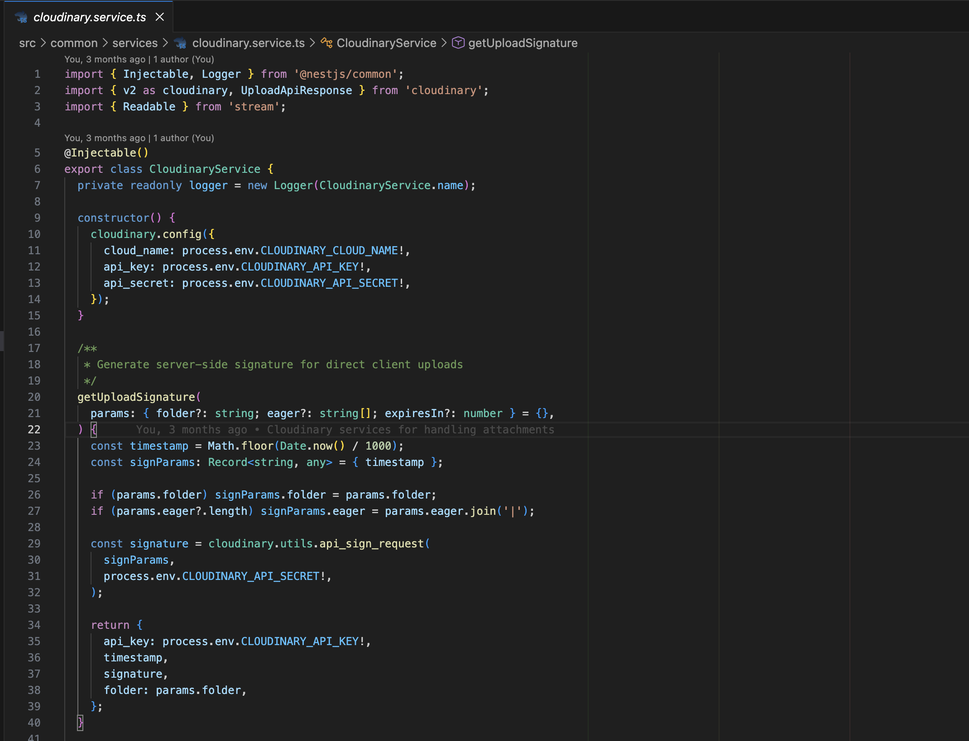

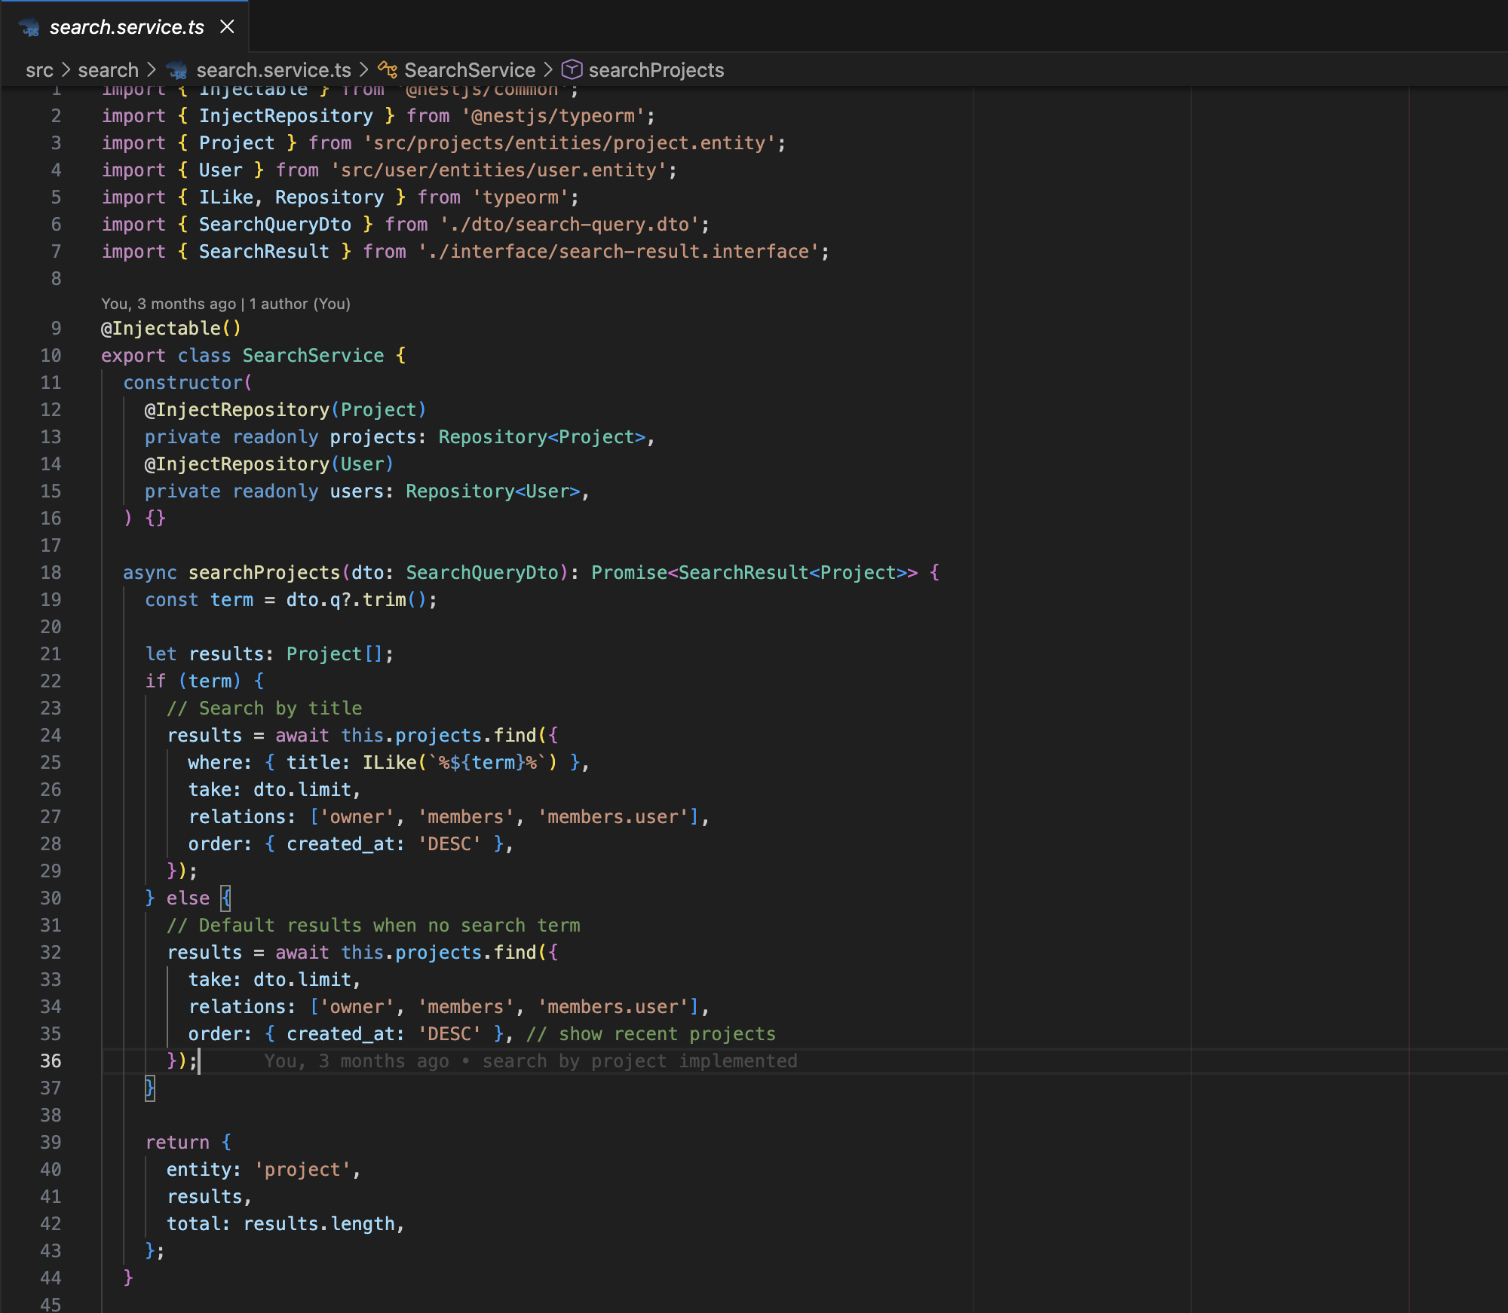

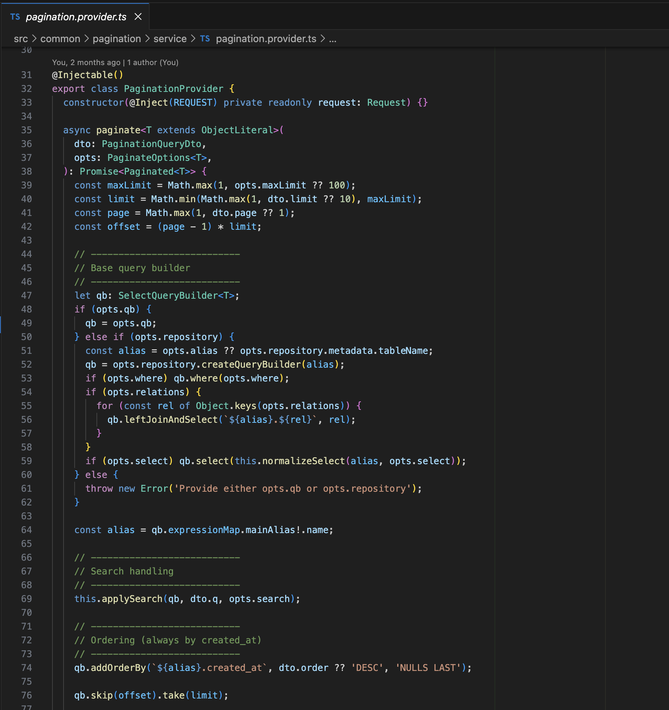

Week 9: Reporting & Data Analysis APIs

In the ninth week, the Performance module was developed to support reporting and analytics. Aggregated database queries were implemented to generate summarized project and task data suitable for graphical representation and progress analysis.

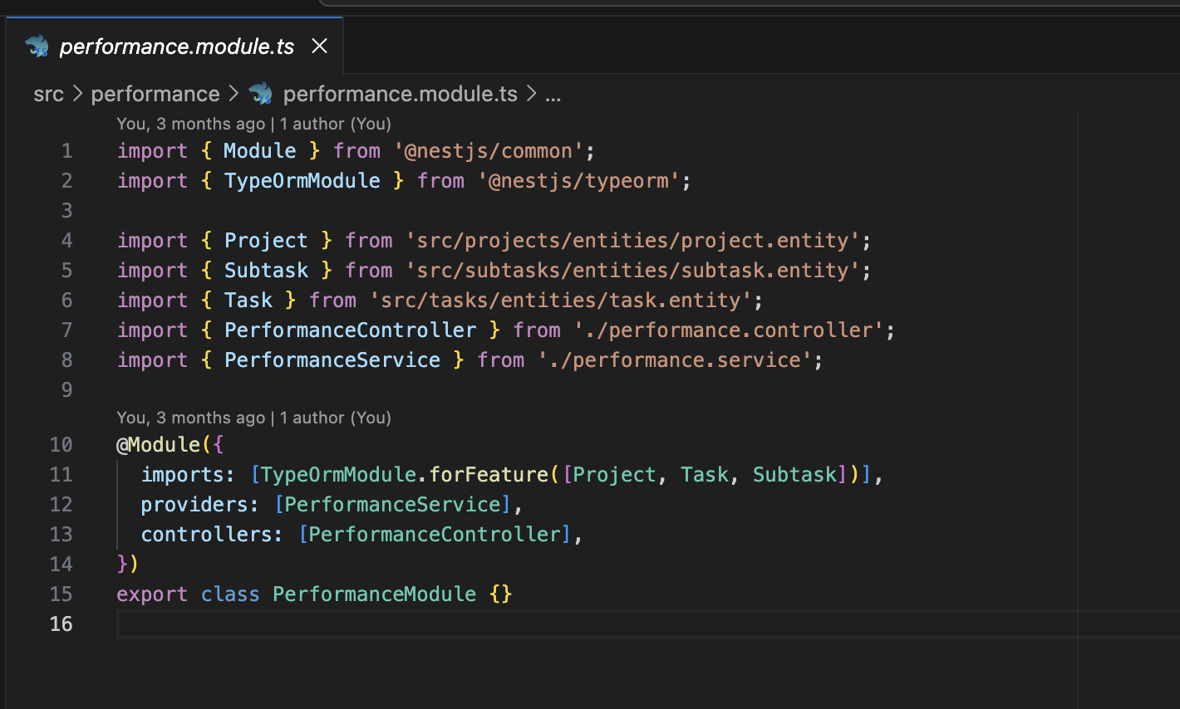

Week 10: System Optimization & Protection

This week focused on optimizing system performance and improving security. Database queries were optimized, and pagination was refined to improve response time. Request rate limiting and additional security configurations were applied. Minor issues identified in earlier modules were fixed during this phase.

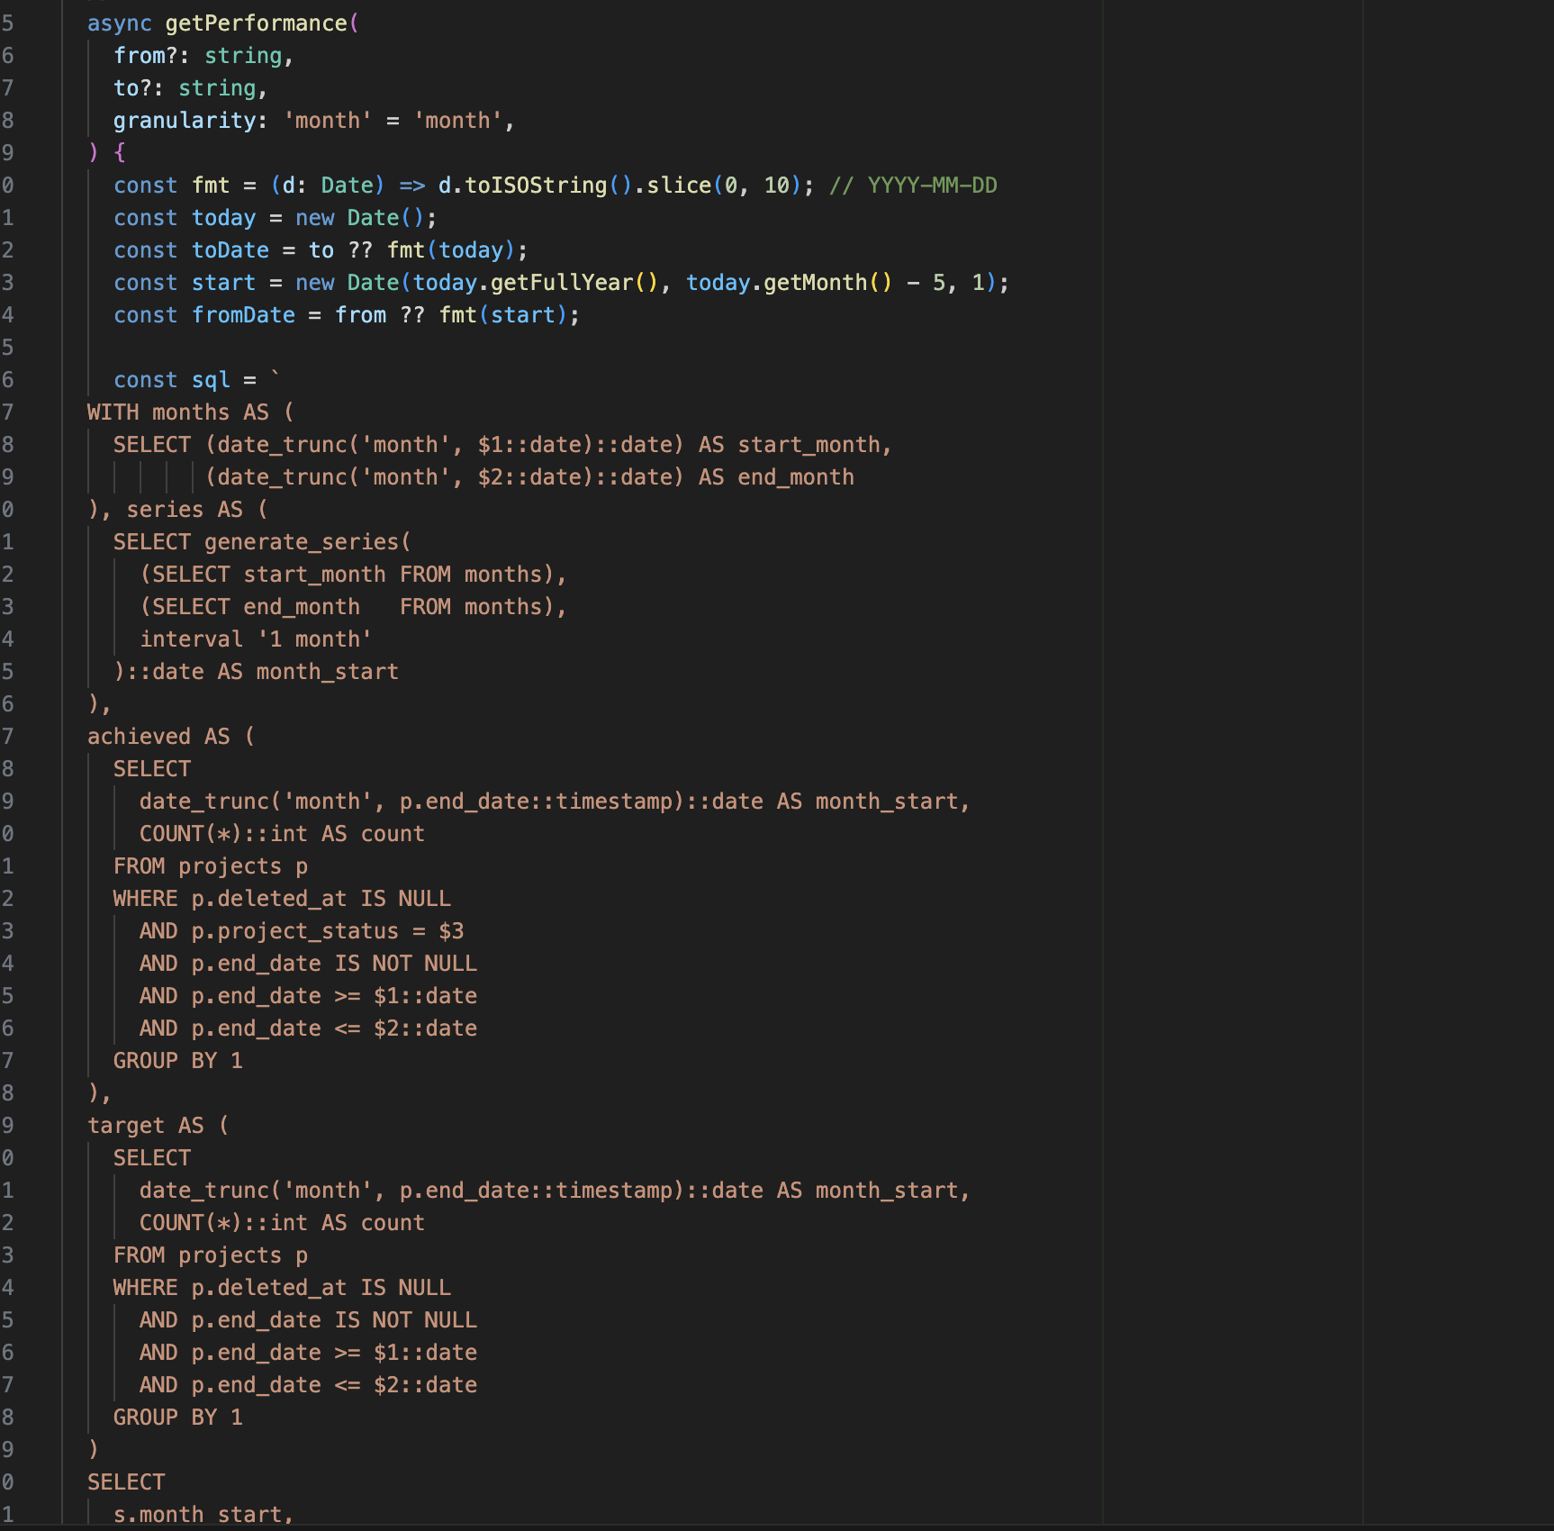

Week 11: Quality Assurance

During this week, extensive backend testing and debugging were performed. Errors identified during integration and testing were fixed. Error-handling mechanisms were improved to ensure system stability and reliability.

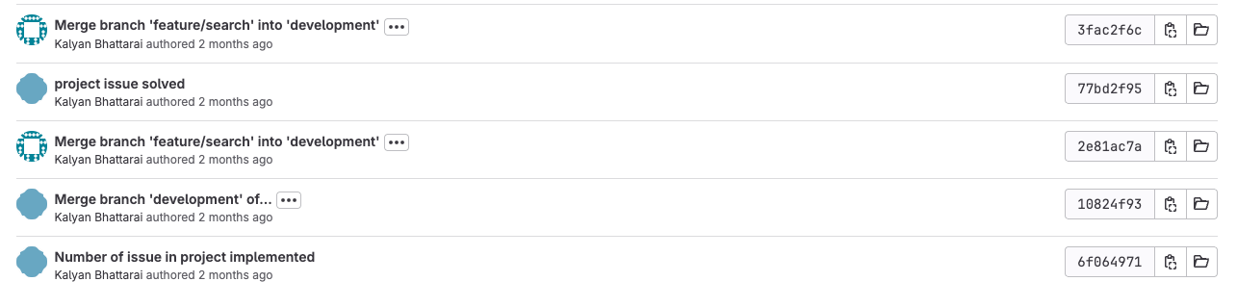



Week 12: Documentation & Finalization

In this week, complete API documentation was prepared using Swagger. The overall backend system was reviewed to ensure all modules functioned correctly. Final deliverables, including documentation and report preparation, were completed.

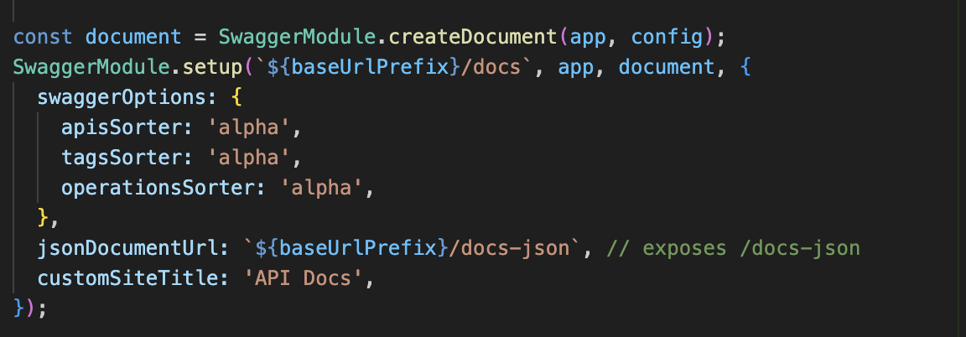

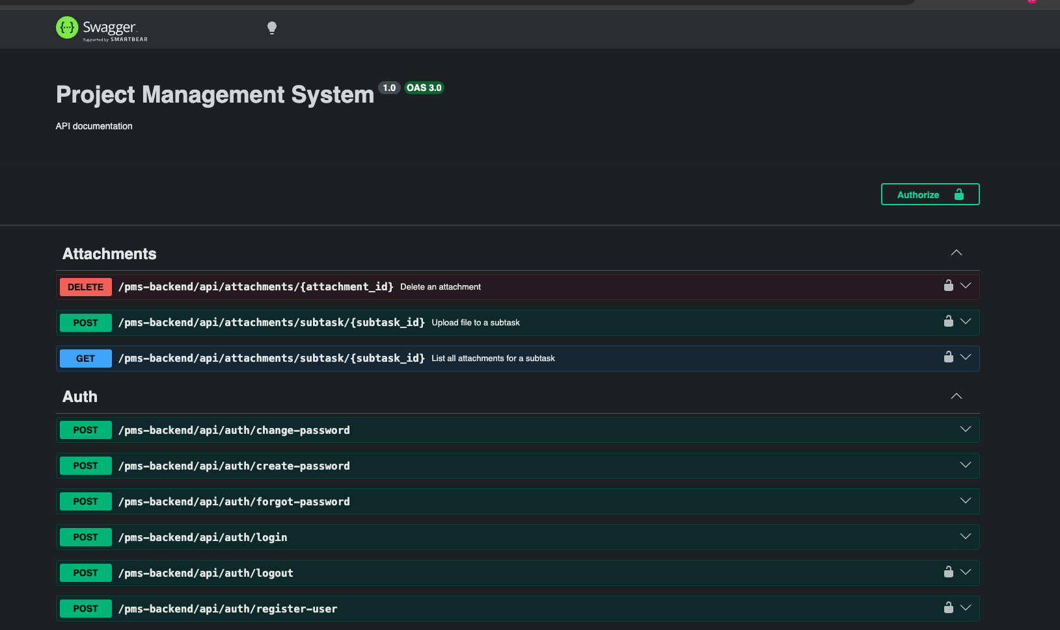

Week 13: Basic DevOps Tools and CI/CD during Deployment

In the final week, basic DevOps concepts were studied. Continuous Integration and Continuous Deployment (CI/CD) pipelines were implemented using GitLab CI/CD to automate build and deployment processes. The backend application was deployed following CI/CD best practices.

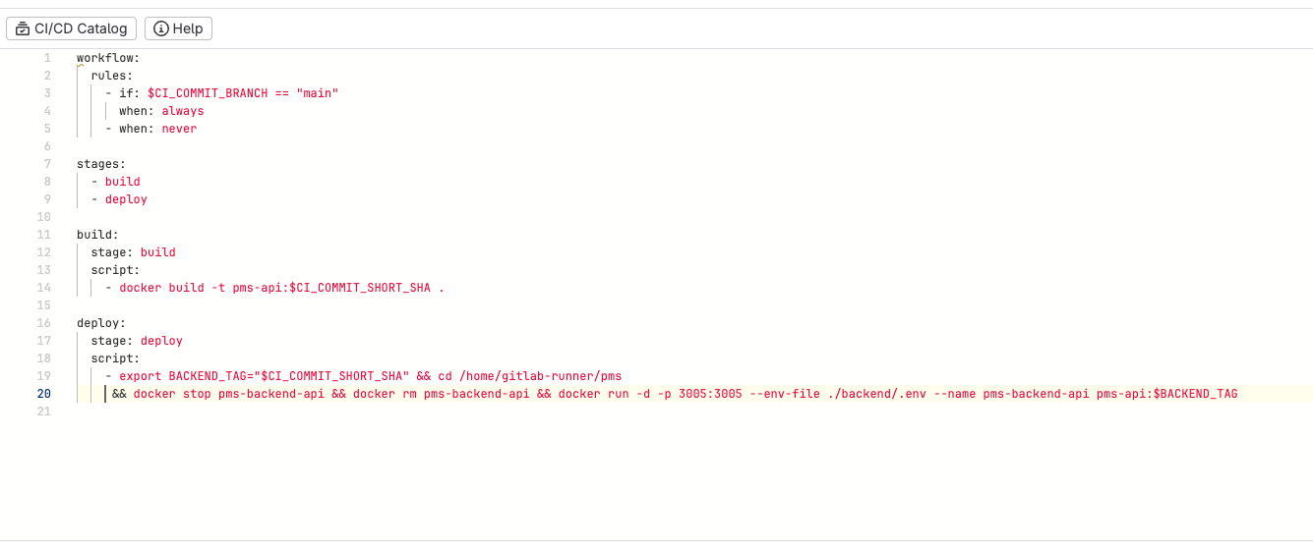

## 3.3 Description of Project Involved During Internship

A Project Management System (PMS) is a software-based system designed to support the planning, execution, monitoring, and management of projects within an organization. It provides a centralized platform where users can manage projects, assign tasks, track progress, collaborate with team members, and maintain project-related information in an organized and secure manner. PMS applications are widely used in software companies and organizations to improve productivity, coordination, and transparency across teams.

In a PMS, users are typically assigned specific roles such as administrator, project manager, or team member, each with defined access permissions. Administrators manage system configurations and user roles, project managers create and oversee projects, while team members are assigned tasks and update their work status. The system ensures that responsibilities are clearly defined and that project activities are carried out according to assigned roles and permissions.

The PMS developed during the internship includes several core modules to support organizational workflows. The authentication and authorization module ensures secure user access using role-based permissions. The project management module allows the creation, updating, and tracking of multiple projects. The task management module enables tasks to be assigned to users, updated with statuses and priorities, and monitored throughout the project lifecycle. Additional modules such as comments and attachments support team collaboration by allowing users to share updates, documents, and feedback within the system.

From a technical perspective, the PMS backend is responsible for handling business logic, managing database operations, enforcing security rules, and facilitating communication between the frontend and the database through RESTful APIs. The system follows clean and modular architecture principles to ensure scalability, maintainability, and efficient performance. Such a PMS enables organizations to manage complex projects more effectively while maintaining data integrity, security, and operational efficiency.

### 3.3.1 Duration

The internship at Web Experts Nepal was conducted over a period of three months, starting from September 17, 2025. The internship followed a standard five working days per week schedule, with daily working hours aligned with the organization’s office timings.

Under the guidance of the assigned mentor, the intern worked as a Backend Development Intern, contributing consistently to the planning, development, and refinement of the backend system throughout the internship duration. This structured timeline allowed sufficient time to understand project requirements, implement features, and improve technical proficiency through hands-on experience.

### 3.3.2 Tools Used

During the internship, various tools and technologies were used for the development and management of the Project Management System (PMS) backend. These tools supported server-side development, API testing and documentation, database management, version control, and team collaboration.

**Visual Studio Code (VS Code):**

A lightweight and powerful Integrated Development Environment used for writing, debugging, and managing the backend codebase. Its extensions and debugging features supported efficient development using NestJS and TypeScript.

**NestJS:**  
A backend framework used to develop the PMS server-side application. It provided a modular architecture using controllers, services, and modules, enabling scalable and maintainable RESTful API development.

**PostgreSQL:**  
A relational database management system used to store and manage structured PMS data such as users, roles, projects, and tasks. Its support for relational integrity and complex queries ensured reliable data handling.

**Swagger:**  
An API documentation and testing tool integrated with NestJS to document RESTful endpoints. It provided a clear interface for testing APIs and understanding request and response structures.

**Postman:**  
An API testing tool used to send HTTP requests, verify responses, and debug backend endpoints during development. It helped ensure the correctness and reliability of PMS APIs.

**Git & GitLab:**

Git was used for version control to track code changes, manage branches, and maintain code history. GitLab served as the remote repository for collaboration, code review, and secure code management.

**Trello:**  
A project management tool used to assign tasks, track progress, and manage deadlines throughout the internship. It supported an organized workflow and clear communication between interns and mentors.

## 3.4 Task /Action Performed

During the internship at Web Experts Nepal Pvt. Ltd., work was carried out on the development of a Project Management System (PMS) using NestJS. The internship primarily focused on backend application development with emphasis on clean architecture, secure API design, and efficient data management.

Initially, time was devoted to understanding project requirements, the development environment, and the existing codebase. Core technologies and tools such as NestJS, PostgreSQL, Swagger, Git/GitLab, Postman, and Trello were used for backend development, version control, API documentation, testing, and task management. After gaining familiarity with the workflow, active contributions were made to backend development activities. The tasks performed included designing and implementing RESTful APIs, developing modules, controllers, and services, managing PostgreSQL databases, and documenting APIs using Swagger. In addition, backend logic was tested, debugged, and optimized to ensure secure data handling, maintainable code structure, and efficient system performance.

# CHAPTER 4: CONCLUSION AND LEARNING OUTCOMES

## 4.1 Conclusion

This internship report presents a comprehensive overview of the work carried out at Web Experts Nepal Pvt. Ltd. as a Backend Developer Intern. The primary focus of the internship was the development of a Project Management System (PMS) backend using NestJS and PostgreSQL. Throughout the internship period, the intern actively participated in real-world software development tasks, gaining practical exposure to backend architecture, RESTful API design, authentication mechanisms, and database management.

The internship successfully bridged the gap between theoretical knowledge gained during academic coursework and practical industry-level implementation. By working on a live project, the intern developed a clear understanding of professional software development workflows, version control practices, task management, and collaborative development environments. The project followed clean architecture principles, modular design, and secure coding practices, ensuring scalability and maintainability.

Overall, the internship experience was highly beneficial in enhancing technical competence, problem-solving ability, and professional confidence. The skills and experience gained during this period will serve as a strong foundation for future career opportunities in backend development and software engineering.

## 4.2 Learning Outcomes

The internship at Web Experts Nepal Pvt. Ltd. provided valuable learning experiences that contributed significantly to both technical and professional development. The key learning outcomes of the internship are listed below:

* Gained practical knowledge of backend development using the NestJS framework.
* Developed a clear understanding of RESTful API design and implementation.
* Learned to design modular and scalable backend architectures following clean coding principles.
* Acquired hands-on experience in relational database management using PostgreSQL.
* Understood the implementation of authentication and authorization mechanisms, including role-based access control.
* Improved skills in API testing and documentation using tools such as Postman and Swagger.
* Learned version control practices using Git and GitLab in a collaborative development environment.
* Gained experience in debugging, testing, and optimizing backend applications.
* Developed professional communication skills through teamwork, reporting, and task coordination.
* Enhanced problem-solving ability and adaptability to real-world software development challenges.

These learning outcomes have strengthened the intern’s readiness for professional software development roles and provided a strong technical foundation for future academic and career growth.

# REFERENCES

Pressman, R. S., & Maxim, B. R. (2015). *Software engineering: A practitioner’s approach* (8th ed.). McGraw-Hill Education.

Fielding, R. T. (2000). *Architectural styles and the design of network-based software architectures* (Doctoral dissertation, University of California, Irvine).

NestJS Official Documentation. (2024). *NestJS: A progressive Node.js framework*. <https://docs.nestjs.com/>

PostgreSQL Global Development Group. (2024). *PostgreSQL documentation*. <https://www.postgresql.org/docs/>

Swagger (OpenAPI Initiative). (2024). *Swagger documentation*. <https://swagger.io/docs/>

Postman Inc. (2024). *Postman API platform documentation*. <https://learning.postman.com/>

Git Documentation. (2024). *Git: Distributed version control system*. <https://git-scm.com/doc>

Web Experts Nepal Pvt. Ltd. (n.d). *Company profile and services*.

<https://www.webexpertsnepal.com/>

# ****APPENDICES****

